HALE2 SECTION A :Short Answers Marks Allotted: 60 marks out of 200(30%).
___________________________________________________________________________________________________
Q1.
A special laser used in eye surgery emits a 3.0 mJ pulse in 1.0 ns at a wavelength of 1 060 nm, focused to a spot 30.0 μm in diameter on the retina.

1a) In what region of the electromagnetic spectrum does this laser operate? (2 marks)

1b) How many photons of light are produced in each pulse? (2 marks)

Q2.
In Young's experiment, light passes through two thin vertical slits in otherwise solid barriers, and is then viewed on a screen.
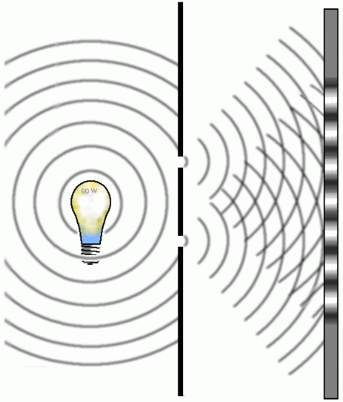

When either slit is covered, a single peak is observed on
the screen from the light passing through the other slit.

When both slits are open, a pattern of light and dark fringes
is observed.

Does this support the wave or particle model of light? Explain.
(4 marks)

Q3.
A typical AM radio frequency is 1000 kHz while an FM radio frequency might be 100 MHz, estimate the wavelengths of typical AM and FM radio signals. Use this information to explain why FM radio stations can fade out when you drive your car through a short tunnel or underpass, when AM radio stations do not. (4 marks)

Q5.
Cycling tracks (velodromes) are banked so riders can travel faster than if the track was not banked.
What is the maximum speed a cyclist could travel around a curve that has a radius of curvature of
27.5 m and is banked at an angle of 42º to the horizontal? (without relying on friction) (4 marks)

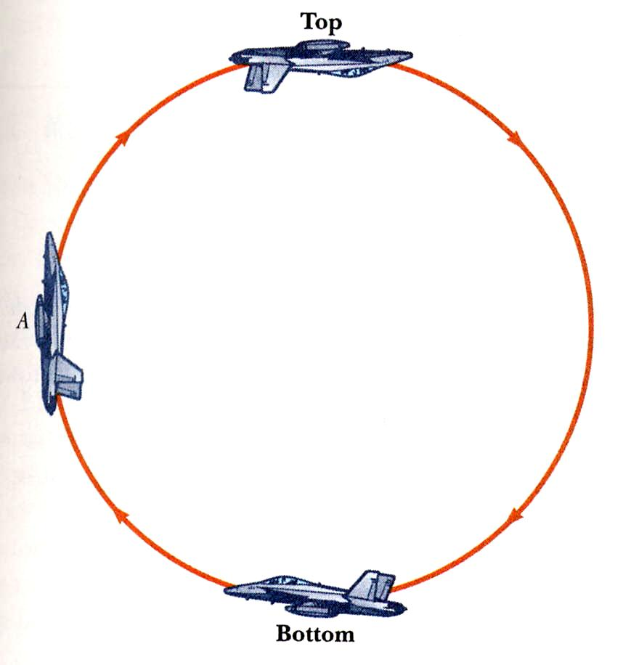
Q6.
At a recent “Red Bull” air spectacular in Perth
aeroplanes performed spectacular aerobatics.

6a) Clearly show (vectors) on the diagram
how the reaction force on the pilot relates
to the net force “experienced” at both the
top and bottom of the loop.
(1 mark)

6b) Calculate the maximum ‘g force’ on a pilot
attempting a “loop the loop” of radius 60 m
in a vertical plane.

The pilot’s mass was 75.5 kg and the speed
was a constant 108 km hr^{– 1}. (3 marks)

Q7.
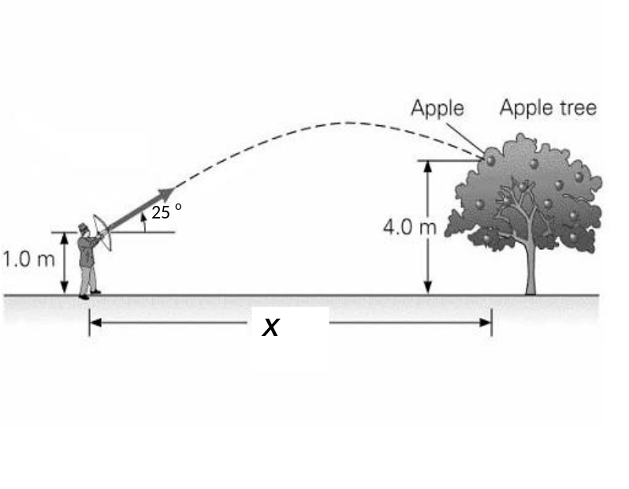
An archer fires an arrow at a speed of
33.0 ms⁻¹ at an angle of 25° to the
horizontal, so that it hits an apple as
shown in the diagram.

Using the information provided,
find the horizontal distance, X
covered by the arrow.
ks)

Q8.
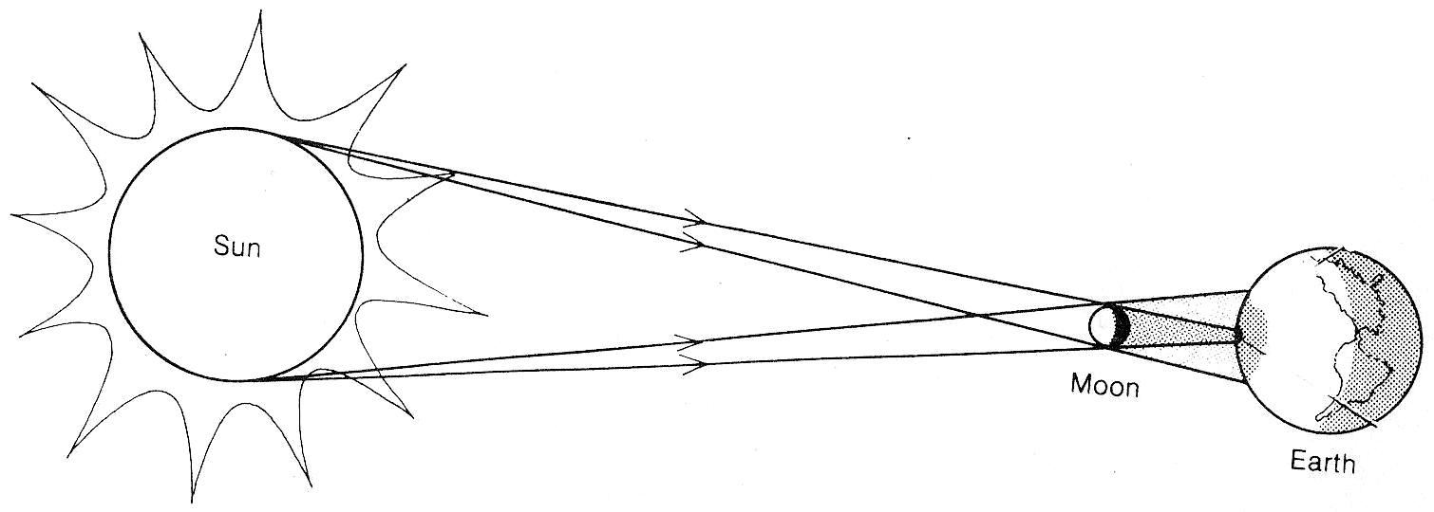
Estimate the resulting
Gravitational force on the Moon
during a Solar Eclipse. Comment
on any significant changes
observed on Earth (apart from the
obvious optical effects) during an
eclipse.

(4 marks)

Q9.
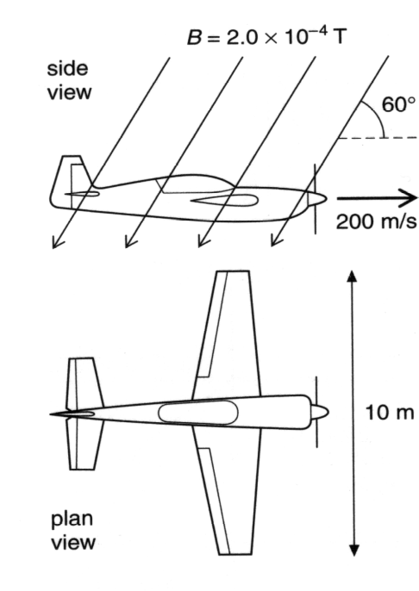
An aeroplane with a wingspan of 10.0 m is flying
horizontally at a velocity of 200 m s⁻¹.
In the region the plane is flying, the Earth’s magnetic field
is 2.0 x 10⁻⁴ T, at an angle of 60º to the horizontal.

What is the magnitude of emf induced across the wingtips
of the plane? (4 marks)

Q10.
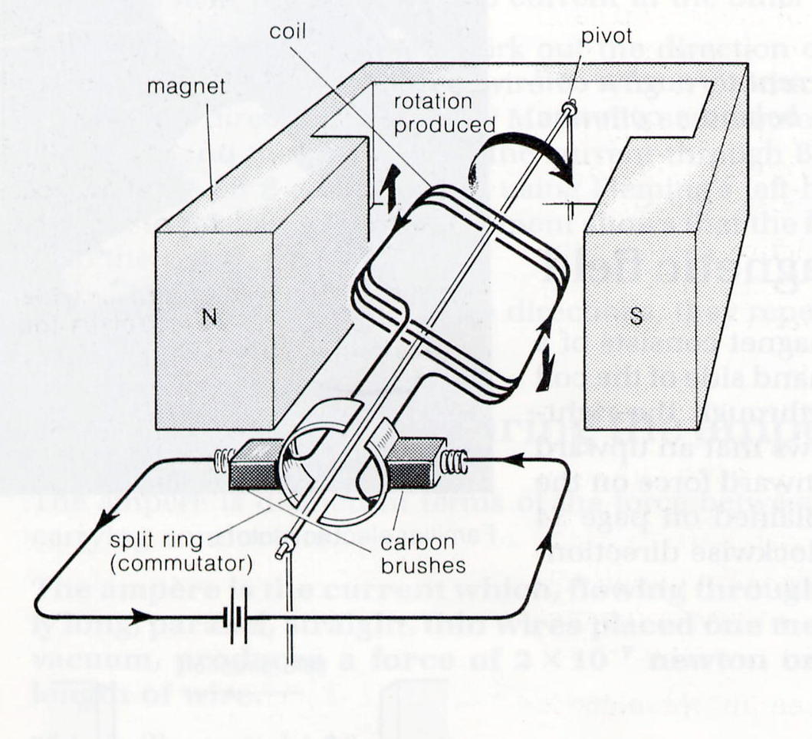
Determine the maximum torque of a simple motor
similar to that illustrated below if the Magnetic flux
density between the poles of the permanent magnet is
1.25 T, the coil consists of 40 turns of wire 22.0 cm long
by 3.0 cm wide and the current supplied is 4.5 A .

Briefly describe the purpose of the split ring
commutator. (4 marks)
Q11.
A transformer for a toy train set plugs into the 240 V
mains supply and changes it to 12.0 V.
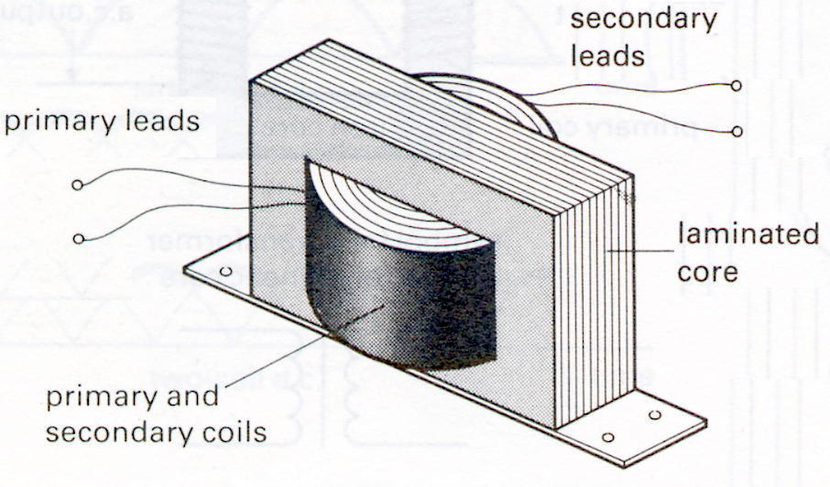
The toy train draws 720 mA from the transformer.

a) If the primary is found to consist of 360 turns of wire,
how many turns will the secondary have? (2 marks)

b) Carefully explain why the core of a transformer
consists of many thin laminated sheets bonded
together instead of a single solid soft iron cast.

(2 marks)

Q12.
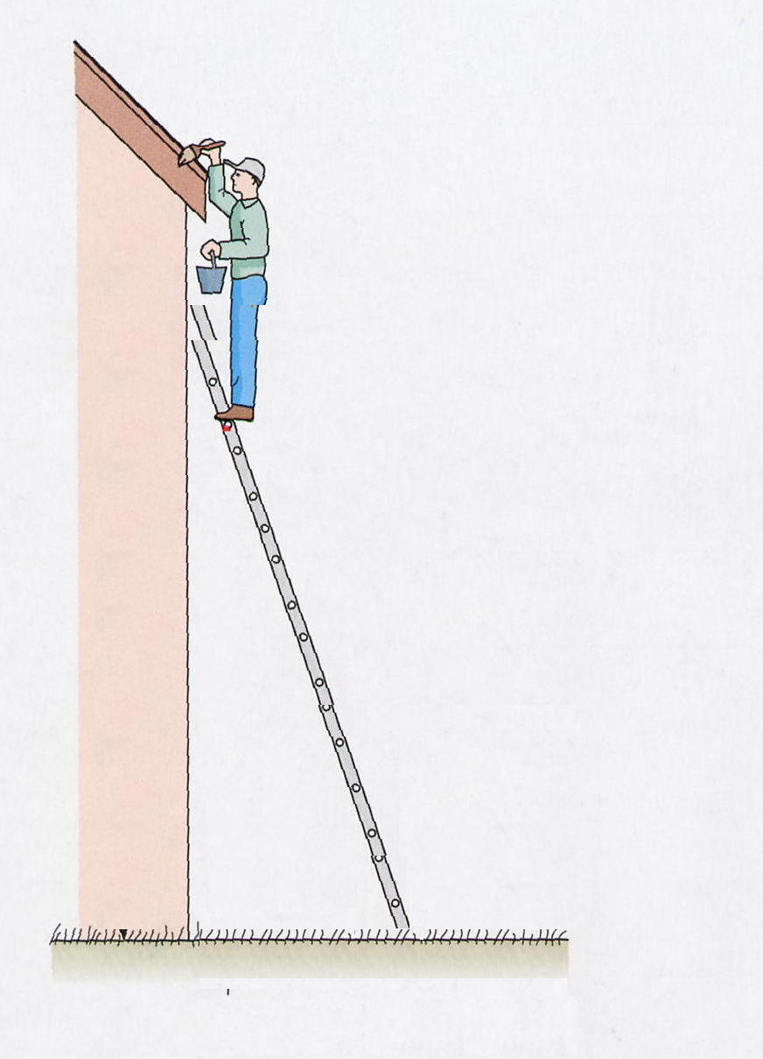
A man climbs a ladder to paint the gutters as shown.

How does the reaction of the ground vary as the man climbs up
the ladder from the ground?

Use a series of vector diagrams to illustrate and explain the change.

(4 marks)

Q13.
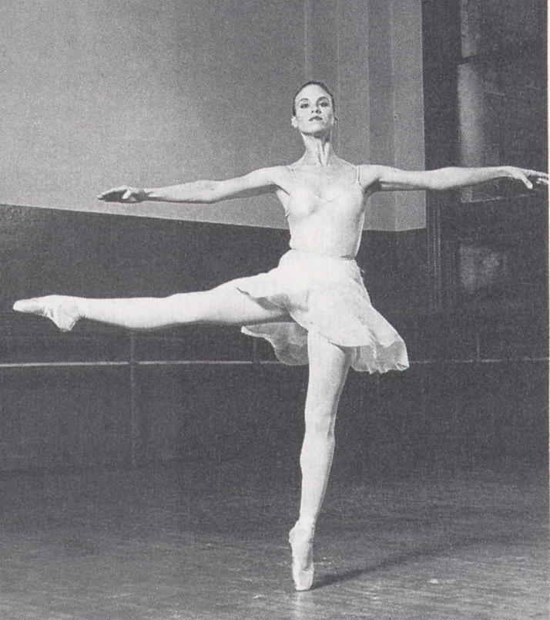
A major skill of a ballet dancer is to maintain balance
(stability) while moving gracefully through the ballet forms
(positions). Demonstrate your understanding of mechanical
stability by describing the movement(s) of the dancer in
terms of their centre of mass.
Carefully explain how this relates to equilibrium and the
principle of moments. (4marks)

SECTION B : Problem Solving
Marks Allotted: 100 marks out of 200 (50%). Attempt ALL 7 questions in this section.
Answers are to be written in the spaces provided.
___________________________________________________________________________________________________
QB1. [11 Marks]
Electric and Magnetic fields are used in mass spectrometers, instruments to measure the masses of
atoms. Ionised atoms are collimated into a narrow beam after being accelerated to a high velocity by
an electric field. They are then fired into a region where there is a strong magnetic field and deflected
around a semicircular arc to be detected by an ion counter (or a photographic plate).
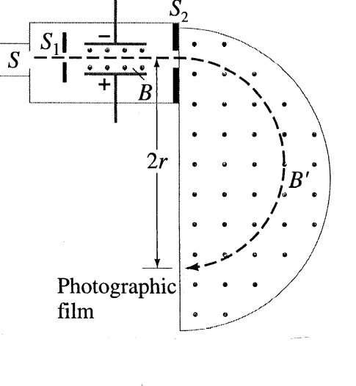
A simplified schematic diagram of such an instrument is shown
The whole apparatus is in a good vacuum.
Consider the application of a mass spectrometer when an ionised
atom with a charge of 4.8 x10⁻¹⁹ C and a mass of 3.64 x10⁻²⁶ kg is
accelerated by a voltage of 6500 V.

1a) In relation to the diagram, what is the inferred polarity (charge)
of the ion? (1 mark)

1b) What is the velocity of the ionised atom on entering the
Magnetic Field Chamber? (3 marks)

1c) What is the size of the magnetic force on such an ion in the deflection chamber when a Magnetic field strength of 0.72 T is operating the mass spectrometer? (2 marks)

1d) What is the minimum distance that the photographic plate should be from the slit in order to
detect this particle? (3 marks)

1e) Carefully describe a practical use for a mass spectrometer. (2 marks)

QB2. [15 Marks]
Some energy levels of the mercury atom are shown in the diagram.
E₁
E₂
E₃
E₄
E_{α}
-0.86 eV
-2.47 eV
-4.71 eV
-10.42 eV
2a) Determine the maximum number of
lines which could appear in the line
emission spectrum of mercury if its
atoms may have a maximum energy
level equal to E4 (-0.86 eV).

(1 mark)

2b) What is the longest wavelength which could be found in that line emission spectrum?

(4 marks)

2c) Mercury atoms in the ground state are bombarded with electrons. What is the minimum velocity
of these bombarding electrons that will ionise a mercury atom?

(3marks)

2d) A beam of light containing only visible wavelengths is passed through a sample of mercury
vapour. Assuming all atoms to be in the ground state, what wavelengths will have a reduced
intensity in the observed spectrum? Provide a reason for your answer and show all working.

(4 marks)

2e) A fluorescent tube is essentially a mercury discharge tube. Briefly describe and carefully explain
how it produces visible light.
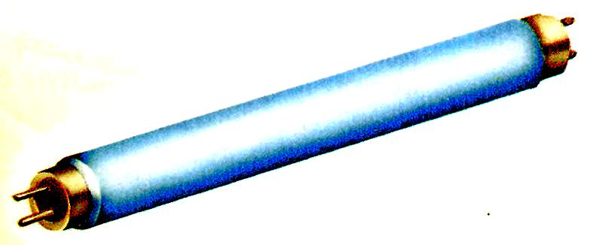

(3 marks)

QB3. [15Marks]
The diagram below shows a simple AC electric generator.
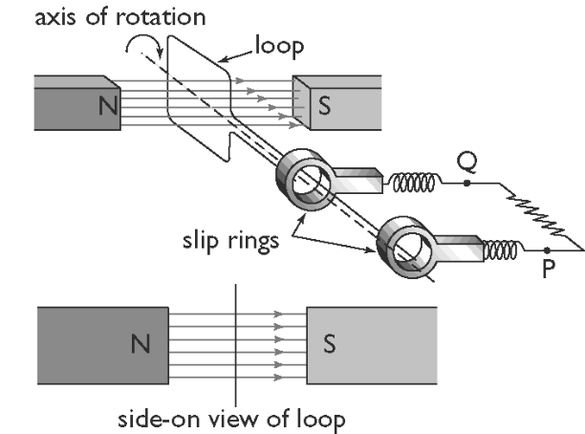
As the loop is rotated in the magnetic field,
an emf is induced.

The graph below shows how the induced emf
varies with time.

3a) Which point, A or B, could possibly
correspond to the point of rotation
shown in the diagram?

(1 mark)
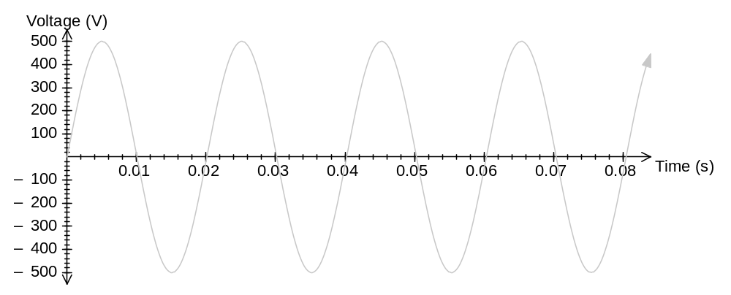

A
B

3b) With what speed, in revolutions per second, is the generator turning?

(1mark)

3c) In a typical single phase AC generator, the average emf induced is 350 V and its rotating coil
consists of 500 turns. Find the magnetic flux (Φ) in the generator.

(4marks)

3d) In a commercial power station, the generators have electromagnets to provide the magnetic
field. What are some of the advantages and disadvantages of this design principle?

(3marks)

At Pinjar power station, the electricity is produced at 350 V and then stepped up to 132 kV before it is transmitted to the city.
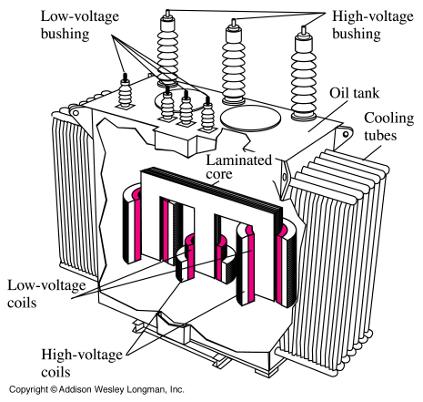

3e) The transformer has an extensive cooling system
to remove the large quantities of heat produced.
Why does the transformer produce this heat?

(2marks)

3f) Why is it necessary to step up the voltage before it is transmitted?

(2marks)

3g) Why is electrical energy transmitted from generator to consumers using an alternating current?
(2marks)
QB4. [12 Marks]
In 10 years Global Positioning System [GPS] has gone from the USA military to being navigator tools to being a normal feature in many luxury cars today. They work by transmitting a beam of electro-magnetic radiation from an aerial on your car roof to one of 24 satellites surrounding the Earth. The reflected beam is received also by an aerial on your roof and your location on the ground can be determined to 50 m. In military application the resolution is less than 10 cm.
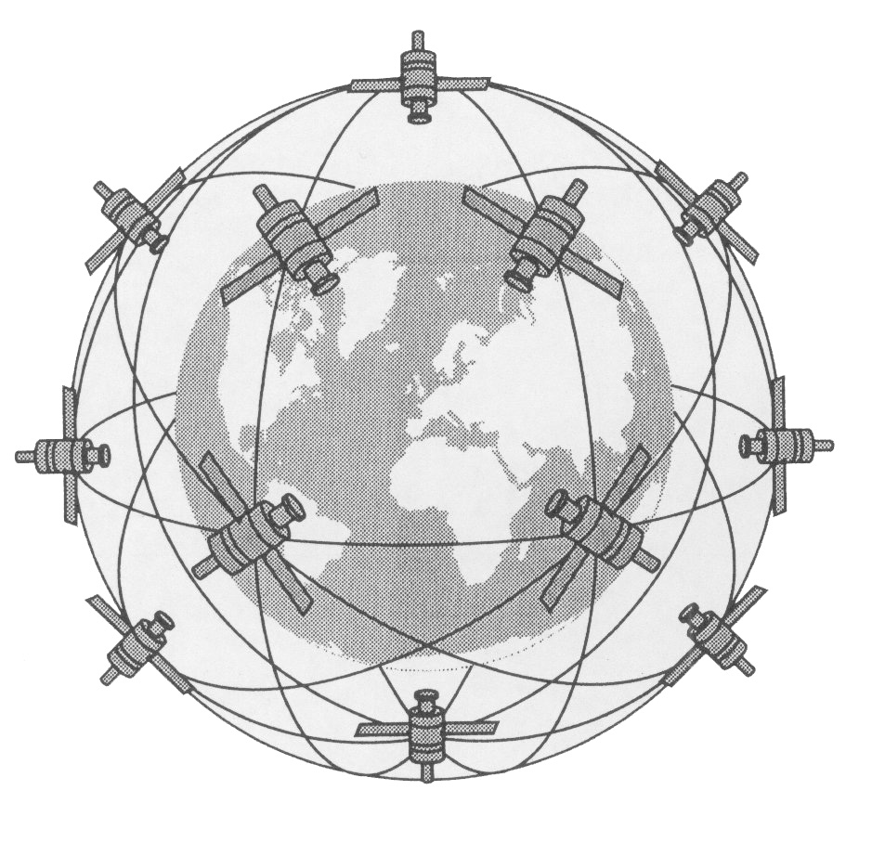
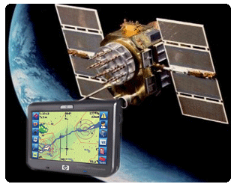

4a) If the height of any one of these satellites is 17 800 km, what is the time for 1 orbit?

(4marks)

4b) Calculate how far such a satellite will travel in 10 mins.

(2marks)

4c) Determine the strength of Earth’s gravitational field at this orbiting height. Note: your answer
must be express in appropriate units.

(3marks)

4d) Carefully explain why so many satellites are required and why they not in a geostationary orbit.

(3marks)

QB5. [14 Marks]
A person bending forward to lift a load “with his back” rather than “with his knees” can be injured by the large forces exerted on the back muscles and vertebrae.

To consider the magnitude of the forces involved in such poor lifting practices, consider the following simplified schematic diagram for a person lifting a 25.0 kg load (L).
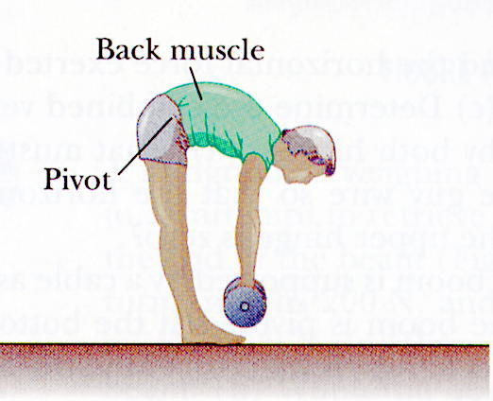
R_{y}
R_{x}
T
W
L
12º
27 cm
32 cm
54 cm

The spine and upper body are represented as a uniform horizontal rod of 41.5 kg (W) pivoted at the base of the spine. The erector spinalis muscle acts at an angle of 12º to maintain the position of the back.

5a) Determine the tension (T) in the erector spinalis muscle while in this position.

(5 marks)

5b) Determine the compressional force on the spine (R_{x}) while in this position.

(3 marks)

5c) Determine the magnitude and direction of the vertical component (R_{y}) of the reaction on the
base of the spine while in this position. Comment on this value.

(3 marks)

5d) Describe and carefully explain the recommended way to lift heavy objects.

(3 marks)
QB6 DELETED
QB7. [17 Marks]
The diagram below shows an experiment to measure the speed of sound in air, v, by determining how the resonance frequency, f, of a thin hollow tube, closed by the water at the lower end, depends on tube length, l.
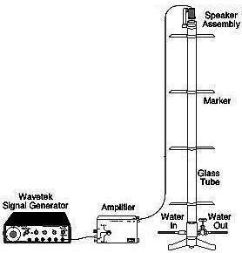

The tube length is adjusted by changing the water
level in the container.

The theory of standing waves in tubes shows that
the set of formulae connecting the variables is:

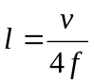
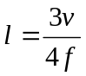
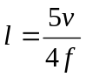
The experiment is conducted as follows:

• The tube is clamped in place while water is
added or removed to set the tube length, l.

• The frequency of sound emitted by a nearby
loudspeaker is varied until the tube resonates
and the resonant frequency is recorded.

• The water level is re-set to give a different
tube length and the new resonant frequency
is found.

The following experimental data was found relating tube length and resonant frequency.
l (m) | 0.625 | 0.364 | 0.313 | 0.156 | 0.938 | 0.469 | 0.625 | 0.625 | 0.727
f (Hz) | 128 | 220 | 256 | 512 | 256 | 512 | 512 | 384 | 330

7a) Describe and explain how you would know that a resonant position had been found.

(2 marks)

7b) Modify the data provided to enable you to plot a straight line graph that shows the relationship
between tube length and frequency. Record the modified data in the bottom row of the table
above. Provide reasoning for your modification.

(4 marks)

7c) Plot your modified data on the graph paper below. Draw appropriate line(s) of best fit.
(Note: There may be more than one line of best fit.) (4 marks)



7d) Explain the reason for any single point not fitting on a straight line.

(2marks)

7e) By using the theoretical formulae and the graph, analyse one of your straight line graphs to
determine the value of the speed of sound, v.

(2marks)

7f) In practice, there are a number of complications in doing this experiment.

Two are: • if the air temperature increases, the speed of sound will increase;

• if we make allowance for the width of the tube, the theoretical formulae
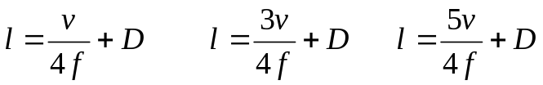
become

where D is a quantity proportional to the width of the tube.

In the space below, carefully sketch three graphs.

• All the graphs should be drawn using the axis below.
• There is no need to include any numerical values on your graphs.
• Label the three graphs (i), (ii), (iii) as follows :

          - The first graph is a sketch copy of one of your graphs from part (b) of this question.

          - The second graph shows how the first graph would be modified if the air temperature was increased.

          - The third graph shows how the first graph would be modified if a tube of larger width was used.

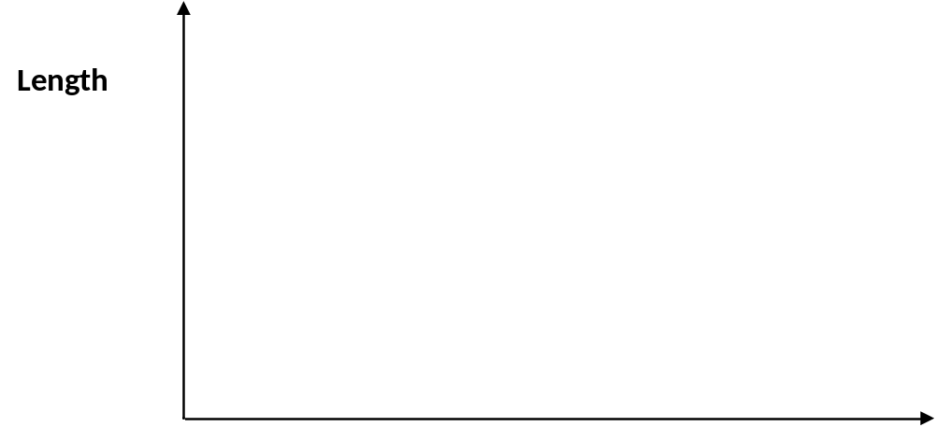

(3marks)
This page has been left blank intentionally.
SECTION C : Comprehension and Interpretation
Marks Allotted: 40 marks out of 200 (20%). Attempt BOTH questions in this section.
Read both passages carefully and answer all of the questions at the end of each passage.
Candidates are reminded of the need for clear and concise presentation of answers.
Diagrams (sketches), equations and/or numerical results should be included where appropriate.
___________________________________________________________________________________________________

X-Ray Diffraction
Paragraph 1

Diffraction can occur when electromagnetic radiation interacts with a periodic structure whose repeat distance is about the same as the wavelength of the radiation. Visible light, can be diffracted by a grating that contains scribed lines spaced only a few thousand angstroms (1 angstrom = 10⁻¹⁰ m) apart, about the wavelength of visible light. X-rays have wavelengths on the order of angstroms, in the range of typical inter-atomic distances in crystalline solids. Therefore, X-rays can be diffracted from the repeating patterns of atoms that are characteristic of crystalline materials.
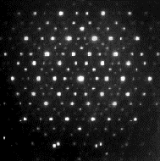
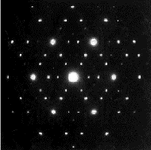
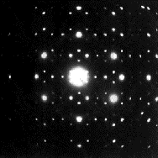

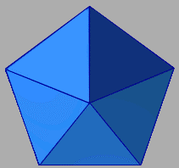
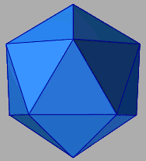
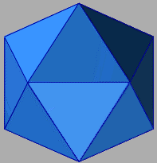

Figure 1. Characteristic Diffraction Patterns of crystalline materials

Paragraph 2 -Electromagnetic Properties of X-Rays

The role of X-rays in diffraction experiments is based on the electromagnetic properties of this form of radiation. Electromagnetic radiation such as visible light and X-rays can sometimes behave as if the radiation were a beam of particles, while at other times it behaves as if it were a wave. If the energy emitted in the form of photons has a wavelength between 10⁻⁶ to 10⁻¹⁰ cm, then the energy is referred to as X-rays. Electromagnetic radiation can be regarded as a wave moving at the speed of light, c (~3 x 10¹⁰ cm/s in a vacuum), and having associated with it a wavelength, λ, and a frequency, f, such that the relationship c = λf  is satisfied.
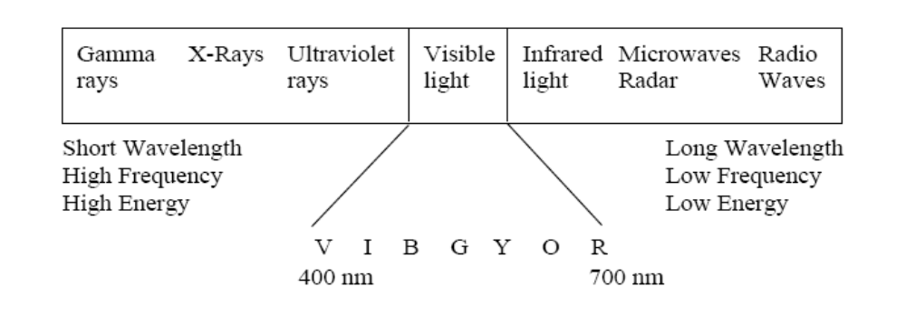

Figure 2. Electromagnetic spectrum. The colours of the visible range of the spectrum are
abbreviated violet (V), indigo (I), blue (B), green (G), yellow (Y), orange (O), and red (R).

Paragraph 3 - X-Rays and Crystalline Solids

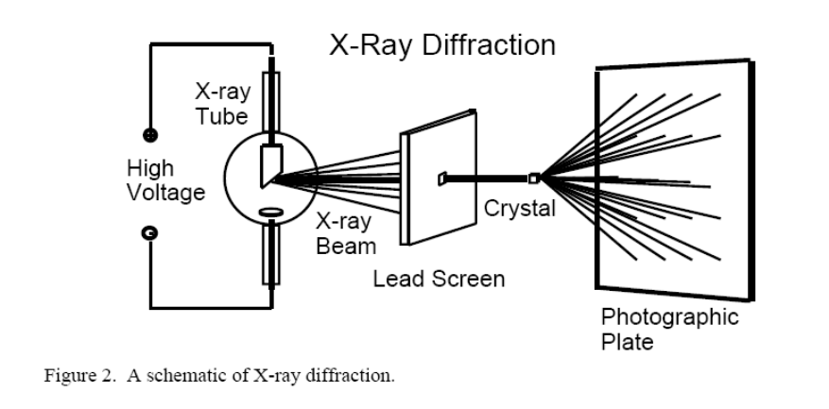
In 1912, Maxwell von Laue recognized that X-rays would be scattered by atoms in a crystalline solid if there is a similarity in spatial scales. If the wavelength and the inter-atomic distances are roughly the same, diffraction patterns, which reveal the repeating atomic structure, can be formed. A pattern of scattered X-rays (the diffraction pattern) is mathematically related to the structural arrangement of atoms causing the scattering.
Figure 3 Schematic of X-ray Diffraction
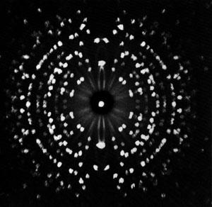

Paragraph 4

When certain geometric requirements are met, X-rays scattered from a crystalline solid can constructively interfere, producing a concentrated beam. Sir Lawrence Bragg simulated the experiment, using visible light with wavelengths thousands of times larger than those of X-rays. He used tiny arrays of dots and pinholes to mimic atomic arrangements on a much larger scale. Optical transform experiments, in which visible light is diffracted from arrays, yield diffraction patterns similar to those produced by shining X-rays on crystalline solids. However, the optical transform experiment is easier and safer than X-ray experiments and can be used in the classroom.

Paragraph 5 - How Diffraction Patterns are Made

High intensity X-rays are directed at a very thin slice of the sample material (a few microns thick) and they diffract through the inter-atomic gaps. . When electromagnetic radiation from several sources overlaps in space simultaneously, either constructive or destructive interference occurs. Constructive interference occurs when the waves are moving in step with one another. The waves reinforce one another and are said to be in phase. Destructive interference, on the other hand, occurs when the waves are out of phase, with one wave at a maximum amplitude, while the other is at a minimum amplitude. Interference occurs among the waves scattered by the atoms when crystalline solids are exposed to X-rays. The atoms in the crystal scatter the incoming radiation, resulting in diffraction patterns. Destructive interference occurs most often, but in specific directions constructive interference occurs.

Paragraph 6 - Purpose of X-Ray Diffraction

Diffraction data has historically provided information regarding the structures of
crystalline solids. Such data can be used to determine molecular structures, ranging from simple to complex, since the relative atomic positions of atoms can be determined. X-ray diffraction provided important evidence and indirect proof of atoms. Diffraction patterns constitute evidence for the periodically repeating arrangement of atoms in crystals. The symmetry of the diffraction patterns corresponds to the symmetry of the atomic packing.

Paragraph 7

X-ray radiation directed at the solid provides the simplest way to determine the inter-atomic spacing that exists. The intensity of the diffracted beams also depends on the arrangement and atomic number of the atoms in the repeating motif, called the unit cell. Thus, the intensities of diffracted spots calculated for trial atomic positions can be compared with the experimental diffraction intensities to obtain the positions of the atoms themselves.

Questions

1. Why are X-rays and not visible light used to analyse crystal structure? (paragraph 1)

(3marks)

2. In figure 3, a narrow beam of x-rays emerges from the lead screen. When this narrow beam
emerges from the crystal under analysis, it “fans out”. Why is this?

(2marks)

3. Why did Bragg experiment with pinholes and dots? (paragraph 4)

(2marks)

4. Estimate the spacing between the pinholes that Bragg used to simulate X-ray diffraction
(paragraph 4). Hint: Information on the data sheet will be helpful

(2marks)

5. How do x-ray diffraction ‘photographs’ differ from x-ray shadow photographs used by doctors
to diagnose broken bones?

(2marks)

6. Why is x-ray diffraction used to analyse crystalline solids (such as a salt crystal), but would not
be suitable for analysing a structure such as wood?

(3marks)

7. How does the method of x-ray diffraction provide evidence for the existence of atoms?
(paragraph 6)

(3marks)

8. X-rays are well known for their ability to penetrate deep inside solids. Is this property essential
for X-ray diffraction? Explain.

(3marks)

Physics in the kitchen
[Freely adapted from C.J. Myers “Domestic Science, Physics Bulletin, 1973, 24, pp 350-52.]

Paragraph 1

The applications of science in the kitchen have been growing steadily and almost unnoticed over the years. Time switches and thermostatically controlled cookers ae common-place and the idea of cooking with infra-red and microwaves nowadays barely raises an eyebrow. One of the latest developments is to make use of electromagnetic induction in cooking. A current is induced in the pans but the cooking stove itself never gets hot –you can only burn yourself on the saucepans.
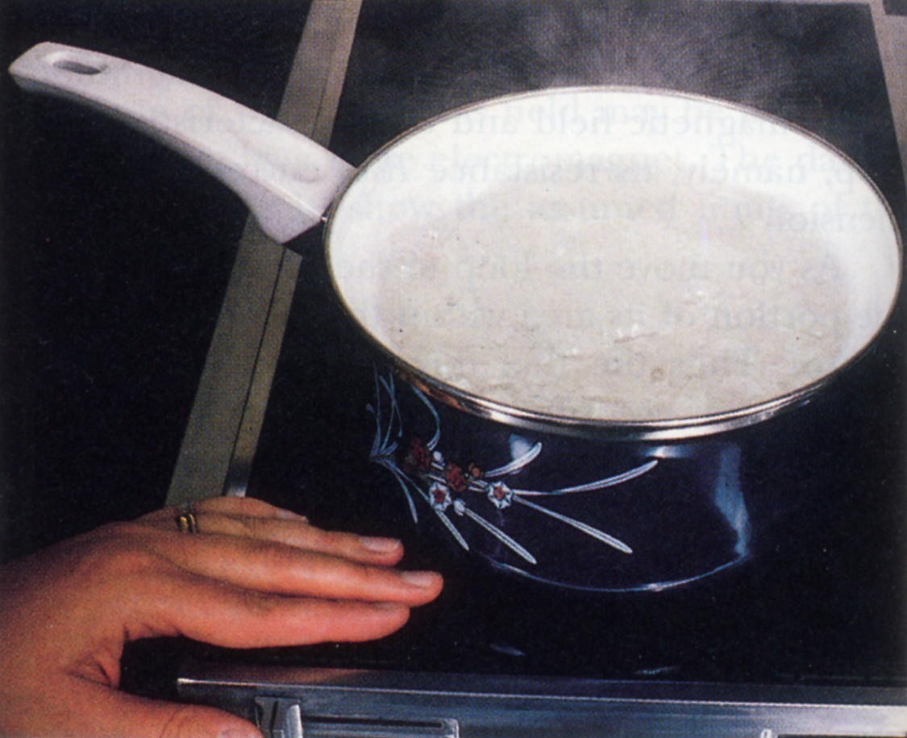
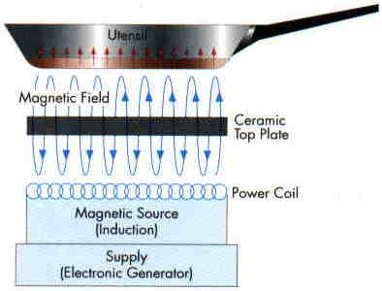

Paragraph 2

Inside the stove are coils, each one corresponding to one of the cooking areas marked out on the glass-ceramic cook top. To start cooking, a rapidly alternating current is passed through a coil; this generates an oscilating magnetic field around the coil which in turn induces an electric current inside the cooking vessel. Obviously an electric current can be induced in anythic metallic, but since a vessel of optimum resistance, copper is ruled out. Iron or steel can be used and these materials have the advantage that the induced current tends to be confined to a thinner layer which increases the resistance and hence power dissipated in the utensil. If a copper kettle is used a device automatically cuts in to limit the current and the stove turns itself off if a pan boils dry.

Paragraph 3

An oscillator produces the high frequency
current needed, which is over 18kHz, and
the device runs off a standard 240 V, 60 A
power supply.

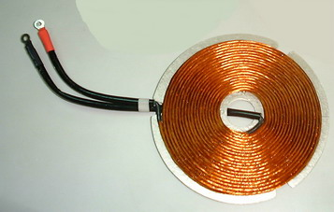

Paragraph 4

Some of the above principles are also used on a different scale in an attempt to solve a problem which seems to have caused a great deal of trouble –that of lighting a gas jet. This latests in a long set of different gadgets is transitorised. It produces a spark within 30μs which means that the gas is ignited almost immediately, avoiding a massive and dangerous build up of gas. The whole unit is powered by a 1.5 V battery which drives the oscillator circuit connected to a coil. A second coil steps up the 20V pulses from the oscillator to 300 V which are used to charge the main 1.5 μF capacitor.

Paragraph 5
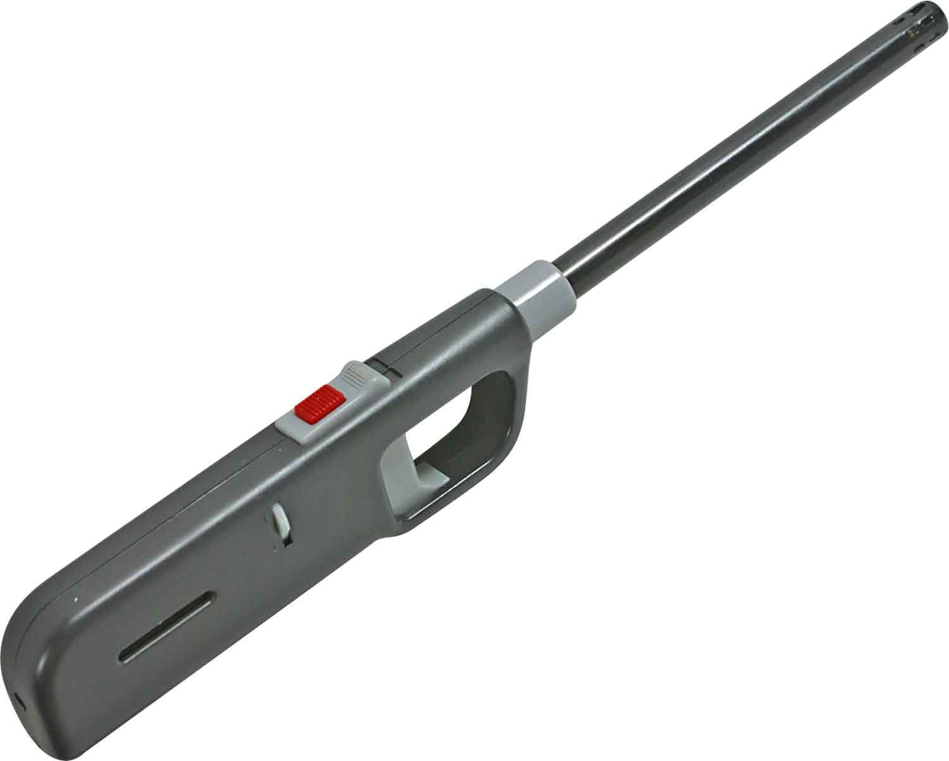

The oscillator produces some 5000 pulses per second
and takes about 1000 pulses before the capacitor is
fully charged. When the chrage reaches a predtermined
level, the capacitor is discharged rapidly (via gas-filled
gap set to breakdown at a preset voltage) through the
primary of a transformer giving up tp 15 kV at the spark
gap. The typical energy of each spark is 1 mJ and the
device will continue sparking at regular intervals.

One interesting point is that the energy supplied at the
spark gap is independent of the state of the battery,
thus always ensuring a successful ignition.

Questions

1. A cook using an induction stove can turn on the appliance, touch the cooking area and not get
burnt. Explain the principle of the stove and why the user would not get burnt in this situation.

(3marks)

2. A friend is concerned that this type of cooking might give her a shock if she touched a pan while
it was being used. Explain why this is not possible.

(2marks)

3. Explain why a copper kettle or a glass saucepan can not be used on an induction cook-top.

(3marks)

4. The high frequency coil and cooking vessel system can be considered to act as a transformer.
a) If electricity is transferred to the cooking vessel at a rate of 2.00 kW and the resistance of
the vessel is effectively 2.00 Ω, find the current flowing in the vessel.

(3marks)

4. b) If the supply voltage to the cooker is 240 V, what current is drawn from the mains?

(3marks)

5. Would a DC current be suitable for an induction cooker? Explain.

(3marks)

6. Some metals such as nichrome have a particularly high resistance. What would be the most
likely consequence of using a cooking utensil made from a metal with very high resistance?

(3marks)

